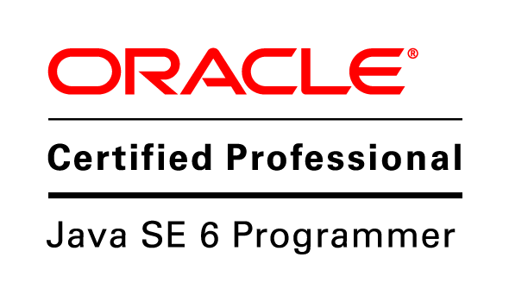
RAJ KUMAR GUPTA
Flat no 404, Block A,
Keerthi Signature, ITPL Road,
Bangalore- 560048
Mobile: +91-9538966001
Email: rajkgupta.me@gmail.com

PROFILE

ANDROID DEVELOPER Feb 2013 – Present
JS Webtech Pvt. Ltd.

I am working as an android developer with experience in designing, coding and testing
of applications. I am proficient in the assortment of technologies including Core Java.

ACADEMIC CREDENTIALS

- Completed B.TECH in Information Technology with CGPA 7.06 from National Institute of Science & Technology, Berhampur in 2013.
- Completed 12th in Science (ISC Board) with 63.7% from MGM English Medium School, Rourkela in 2009.
- Completed 10th (ICSE Board) with 67.5% from Saint Mary’s English Medium School, Rourkela in 2007.

PROJECT INVOLVED

I Remember.
Description: This is a location based application which helps user to find the places such as Restaurant, Shops, Parks, Banks, ATM, Bus stops, Hospitals, etc.
It will show the result in a list based on nearby or anywhere distance and the user can select the places from the lists which will shows direction to the destination in Google map.
Used:
- GooglePlayService Api
- Google Maps
- Direction Api
- Json Parsing
- Android SDK
- Eclipse
Language: Core Java.
Tools: Android SDK, Eclipse.

Daily Expense Manager.

Description: The main aim of this application is to manage our daily expenses that are done either by cash or through credit card. The transaction can be added manually when it is paid through cash and the transaction will be updated automatically by receiving the SMS in mobile when credit card is swiped.
The transaction report can be generated in desire date range and transaction report can be saved in sdcard or it can be mailed to the user email id in xls format.
The user can set reminder for the payment of credit card.
Used:
- SQlite Database
- JExcelApi
- JavaMail Api
- Android SDK
- Eclipse
Language: Core Java.
Tools: Android SDK, Eclipse.

FIFA Live.
Description: This application keeps you informed about the FIFA Football World Cup 2014, in Brazil. It also provides an insight into the history of the World Cup, Live Scores, Match schedule, Point table, Teams, Players and Groups.
Used:
- SportsData Api
- Json Parsing
- Android SDK
- Eclipse
Language: Core Java.
Tools: Android SDK, Eclipse.

SmartEdu.
Description: This application helps school and colleges to establish a strong tracking system for the students, where user track Candidate daily class progress, Attendance, syllabus, Exam schedule, Exam result, Health, Mental status, Psychological status, Diet plan and Motivation factors. This application also helps teacher and parents to track the growth of students.
Used:
- Json Parsing
- Android SDK
- Eclipse
Language: Core Java.
Tools: Android SDK, Eclipse.

ACADEMIC PROJECT

Bulletin Board application.

Description: Project is based on android platform which checks the server if there is any new news available if yes then it will track the new information and display in the android device.
TECHNICAL SKILLS

- Proficient in: Core Java, C, C++.
- Platform: Android, Windows.
- Web Technologies: HTML, SQLite.
- Knowledge of Hybrid Mobile application.

CERTIFICATION:

- Oracle Certified Java Professional, Standard Edition 6 Programmer (OCJP).

EXTRA-CURRICULAR ACTIVITIES

- Attended four days Aakash android workshop conducted by IIT, Bombay.
- Presented a paper on “Osmotic Power for electricity generation” in Sankalp’11.
- Active member of PETA (People for the Ethical Treatment of Animals).
- Participated in “Band competition” in NIT, Rourkela.
- Attended two days workshop on Robotics conducted by Technophilia.
- Passed the certificate ‘A’ Examination in NCC on 2006 held under the authority of Minister of Defence, Government of India.

PERSONAL SKILLS

- Willingness to learn new things, Team facilitator, Potential worker.
- Dedication and hard work towards achieving the objectives and goal.
- Trustworthy and dependable and can lead a team.

AREAS OF INTEREST

- Working with computers.
- Singing and playing Guitar.

PERSONAL PROFILE

Date of Birth : 28th March, 1989.
Fathers Name : Late Ram Nath Prasad.
Gender : Male
Languages known: English, Hindi, Oriya.
(RAJ KUMAR GUPTA)

